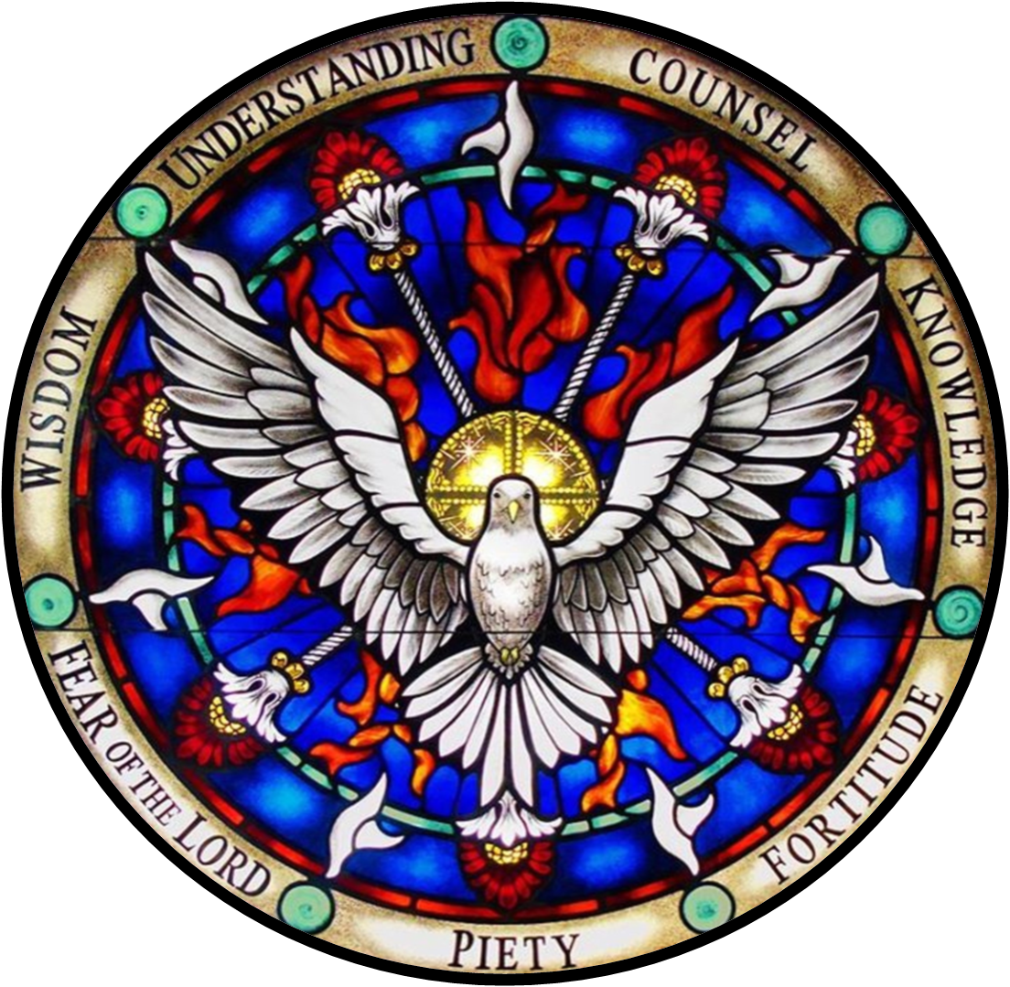
Our Lady Star of the Sea Parish

Marblehead, Massachusetts

Confirmation Requirements

Fall 2023

Candidates will have attended Confirmation preparation classes during the 9th and 10th grades, in-person or virtual.

Candidates attend a retreat in the 11th grade, in proximate preparation for the sacrament.

Candidates will have a 15 minutes’ interview with the Pastor according to a posted schedule.
20 hours of Christian service has been a usual requirement of preparation for the sacrament. Because of Covid-19 restrictions, the full complement of hours are not required this year. However, each Candidate should have some experience of outreach to others in Jesus’ name.

The Christian Service Verification form (see the reverse of this page) is to be used to describe your experience in reaching out to others in Jesus’ name. The form is meant to be copied and filled out for each service that may have been performed.
Examples of Christian service include work for Our Lady Star of the Sea Parish such as Altar Server, Lector, Choir, Religious Ed Teacher's Assistant, help with February food drive, service at Italian night, pancake breakfast or other social occasion, VBS volunteer, church upkeep jobs (painting, etc.), office help, assist at Religious Ed events geared toward younger students such as the Kick-off Party or Cupcake Wars, and more!
Christian service beyond the Parish can include anything done to help a person in need--a friend, neighbor, family or community member. The activity should be unpaid and not part of daily chores. Examples include: nursing home visit, serving at Lifebridge or My Brother's Table, tutoring, volunteering at an animal shelter, participation in a community clean-up, a Walk-a-thon to raise money for a charity, errands for an elderly family member or neighbor, babysitting for free, bake cookies for a homeless shelter, volunteer at the food pantry, make cards for Veterans, and more!
As with all major events in Catholic life, Candidates should plan to make a good confession in preparation for Confirmation.
Each Candidate should now complete and sign the 2023 Candidate Registration Form, and submit it to the Religious Education Office. This form includes the designation of your Confirmation Sponsor. Please consult the confirmation Sponsor Requirements sheet for guidance.
​There will also be a Confirmation rehearsal to be attended in the company of your sponsor, if possible, or by another adult who will instruct your sponsor on what will be expected.
The Sacrament of Confirmation will be celebrated at Our Lady Star of the Sea on Sunday, November 5, 2023 at 2 p.m.

